1. Ultimate Thread Group: verify biểu đồ bằng jp@gc - Active Threads Over Times.

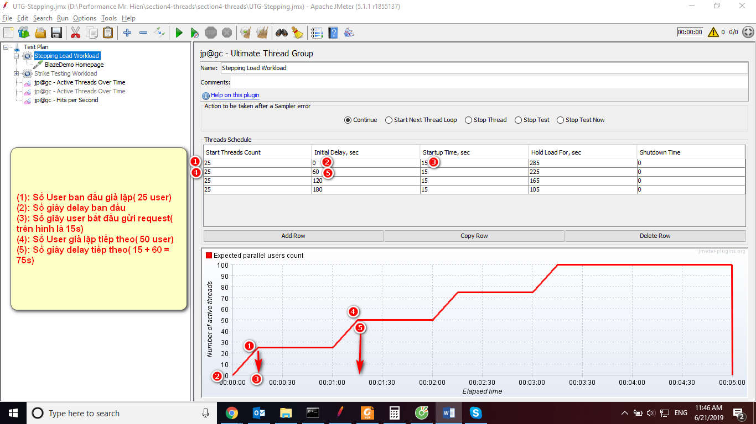

1. Concurrency Thread Group: verify biểu đồ bằng jp@gc - Active Threads Over Times

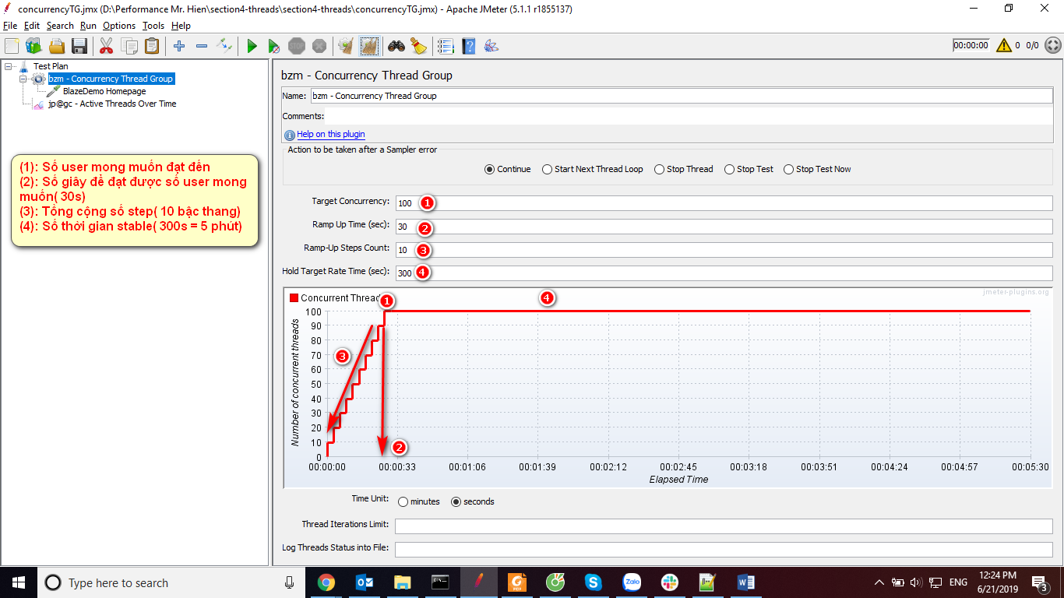

1. Arrival Thread Group: Modify the arrivalTG.jmx to simulate the case when 500 purchasing requests are created in 3 minutes, verify biểu đồ bằng jp@gc - Active Threads Over Times:

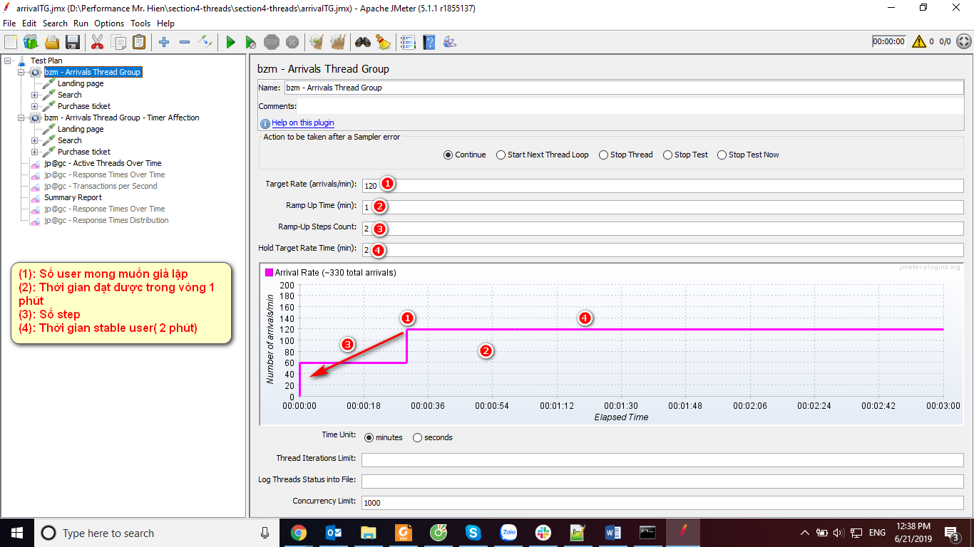

Ví dụ:

Modify the arrivalTG.jmx to simulate the case when 500 purchasing requests are created in 3 minutes